GCSE Geography Fieldwork Revision Notes Table
In Section B of Paper 3, you will answer some questions about unfamiliar fieldwork i.e. you may be shown photos / maps / data about fieldwork in a place that you’ve not been to and you will have to come up with ideas about how you would carry out fieldwork there. After that, there will be questions about your familiar fieldwork i.e. about the fieldwork that you have carried out. The table below will help you to prepare for the familiar fieldwork questions.
Introduction
 |  | Physical fieldwork  River study on Malham Beck, Yorkshire Dales |  | Human fieldwork  Environmental quality in York
1 | State the aim / title of your fieldwork enquiry.
2 | Identify your hypothesis (es).
3 | Explain why this is a suitable topic for a geographical enquiry.
4 | Outline the theory and / or concepts underpinning the fieldwork. Include key terms.
5 | Describe the location of the fieldwork.
6 | Draw a sketch map showing the location of the fieldwork.
7 | Justify why this was a suitable location (explain the advantages of the area where you went to).
8 | Suggest why risk assessment is important when carrying our fieldwork.
9 | Risk assessment: what were the risks and how were they managed?

Methods of data collection
10 | Identify your methods of primary data collection and state whether they are quantitative (Qt) or qualitative (Ql).
11 | Describe in detail how you carried out two primary methods of data collection. You may draw a diagram.
12 | Assess how useful maps, photographs and fieldsketches were in supporting you to achieve your original aims.
13 | Justify how your methods of primary data collection helped you to complete your enquiry.
14 | Describe your sampling strategy and explain why it was chosen.  (i.e. random, systematic or stratified)
15 | Outline any secondary research that was undertaken to support the enquiry.

Methods of data presentation
16 | Describe how you presented your data – choose two methods. Draw a sketch of each.
17 | Assess the effectiveness of each method of data presentation in helping you to analyse your results. (Refer to strength and weaknesses.)
18 | Identify alternative methods that could have been used to present the data.

Data analysis and conclusions
19 | Describe and explain your results.  State the overall trend, refer to evidence (data) from specific sites, give reasons for the pattern, identify anomalies & explain them. Use key terms.
20 | What conclusions can you draw from your data analysis? Refer to your hypothesis (es).

Evaluation
21 | Outline the limitations of your methods of data collection.
22 | Suggest how the limitations of your data collection could have been overcome.
 | Identify any other data that would have been useful to have collected.
23 | Assess how reliable your conclusions may have been. Or…  To what extent were your results useful in helping you to reach a reliable conclusion?
24 | To what extent were your results useful in helping you to achieve the original aims of your enquiry?
25 | To what extent were quantitative methods of data collection more useful that qualitative methods in supporting your enquiry?
26 | With reference to your aims, methods and conclusions, suggest how your fieldwork enquiry could be improved.
27 | For one of your enquiries suggest how the human geography and processes have had an impact upon physical geography.  Refer to your river study and the impact of people upon the river e.g. artificially supporting the river bank.
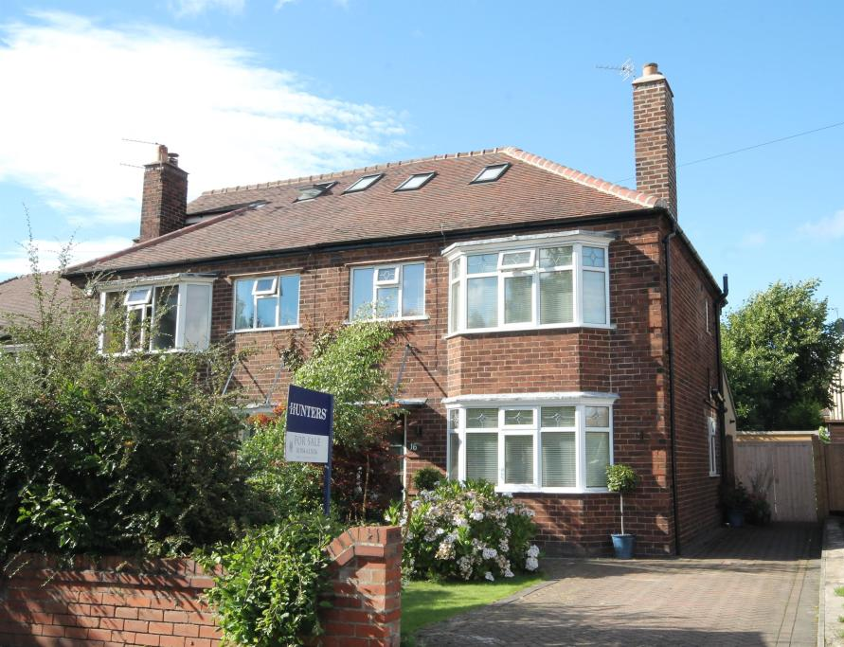
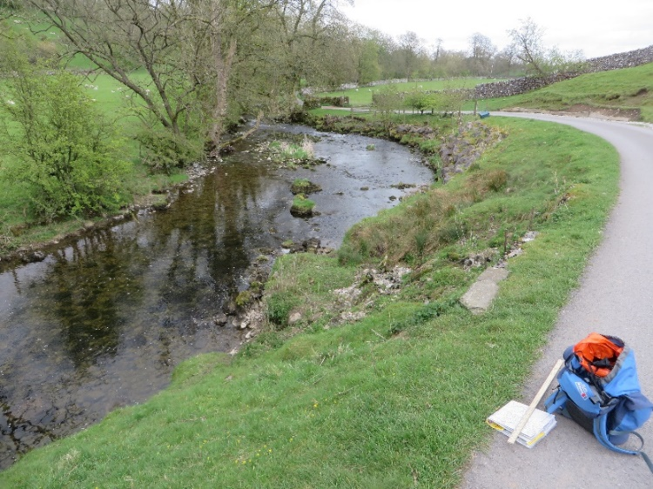
It is likely that the questions about
the familiar fieldwork will be
worth 2, 3, 6 and 9 & 3 SPaG marks.

