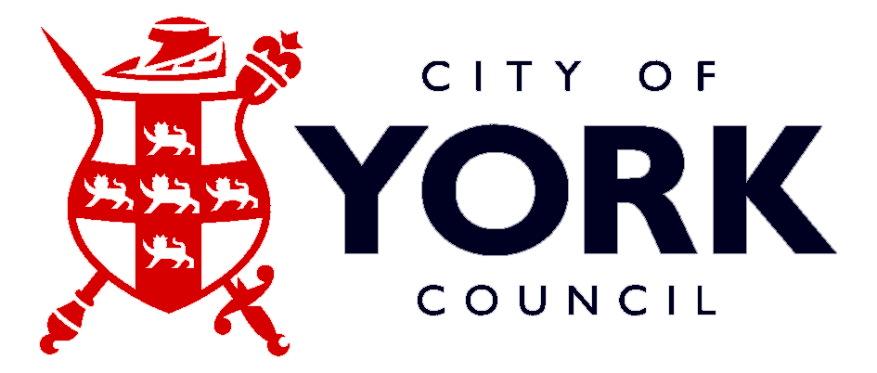
i p
ss
City of York
Independent–State School Partnership
The shape of things to come!
The Dragon's Apprentice
Would you like to meet our panel of dragons? Sir Kenneth Morrison CBE to name just one…

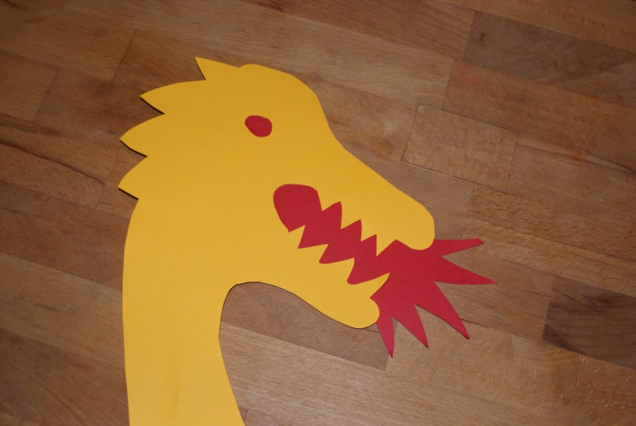
Year 12 students! Join a team of other bright sparks and pitch your team’s ideas for a sustainable future in front of ‘the dragons’
If you have the spark and drive to survive on “The Apprentice” or succeed on “Dragon’s Den”,
if you would like to play an active part in an exciting, sustainable future… Join us!
- build the skills you need through a series of active workshops
- join a team of other creative students from across York
- be guided by your own business guru and put together an exciting pitch
- sell your idea before a panel of rich and famous “dragons” at the showcase final!
The top team wins a VIP tour of FERA (Food & Environment Research Agency) and £50 voucher each…
VENUE: UNIVERSITY of YORK
SATURDAY 12TH 19TH 26TH JUNE (AFTER the AS EXAMS finish) 9.30am to 12:30pm
IF YOU MAKE THE FINAL YOU’LL PITCH IN FRONT OF ‘THE DRAGONS’ ON SUNDAY NIGHT 27TH JUNE…  
IT COULD BE THE BEST THING YOU DO THIS YEAR!! SO SIGN UP
Return your application by Tuesday 11th May
Would you like your own business guru? Are you a budding entrepreneur? Could your leadership and creativity skills do with a boost? Great for your UCAS personal statement & CV!!

