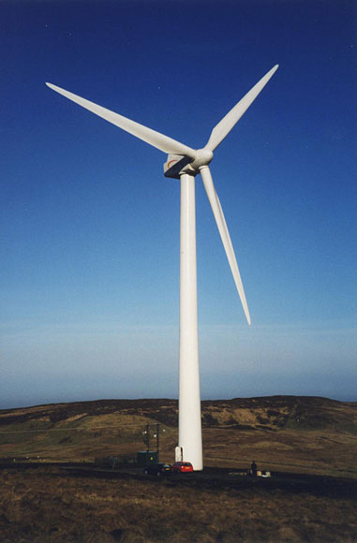

**Why did you choose this place? Think about the landscape and how close it will be to a town. Do you think wind turbines are a good idea?**

**(Answers in full sentences)**

**What are non- renewable resources?**

**Give some examples**

**(Answers in full sentences)**

**Draw a picture of a piece of land that you think would be a good place to have a wind farm.**

**Wind Turbines**

**What are renewable resources?**

**Give some examples**

**(Answers in full sentences)**