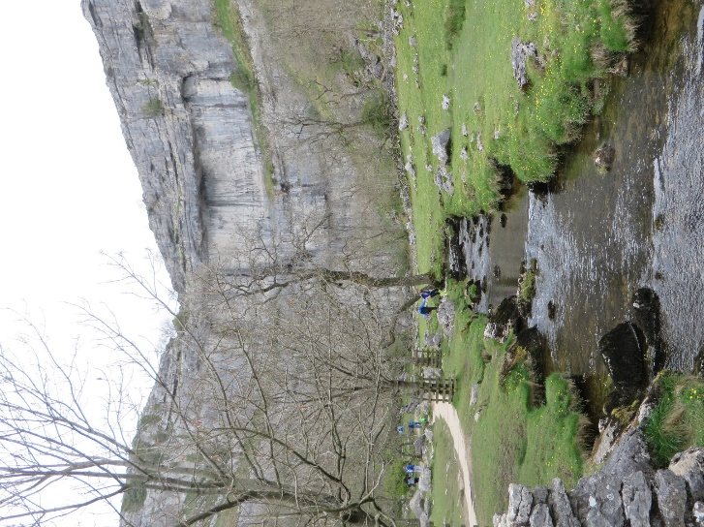 1
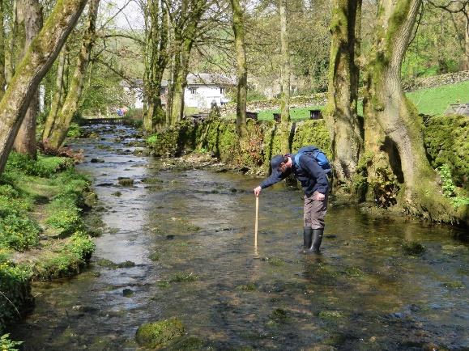 2
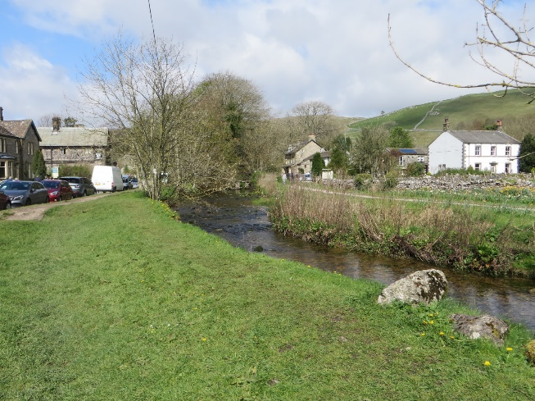 3
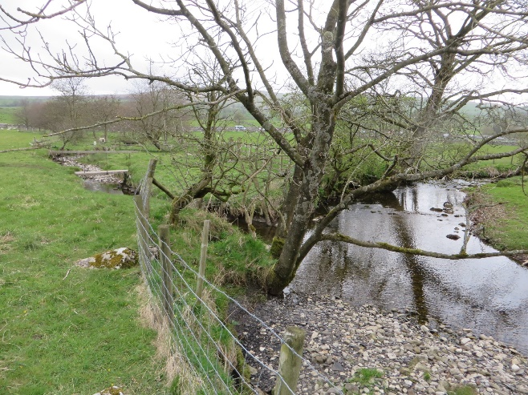 4
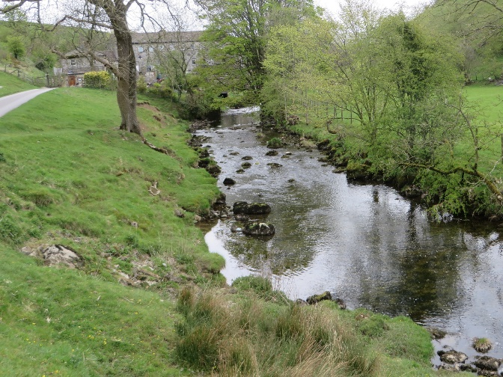 5

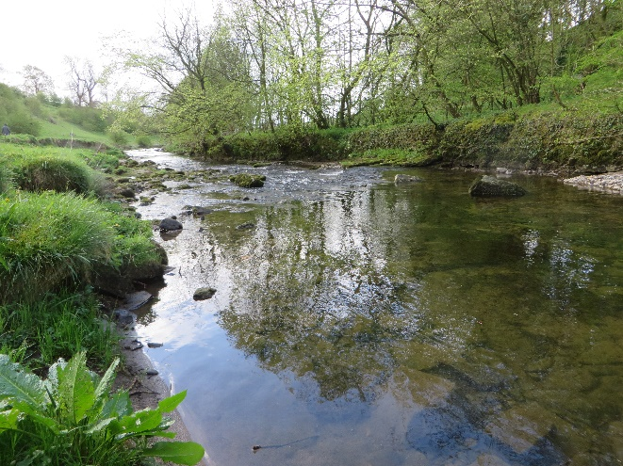 6
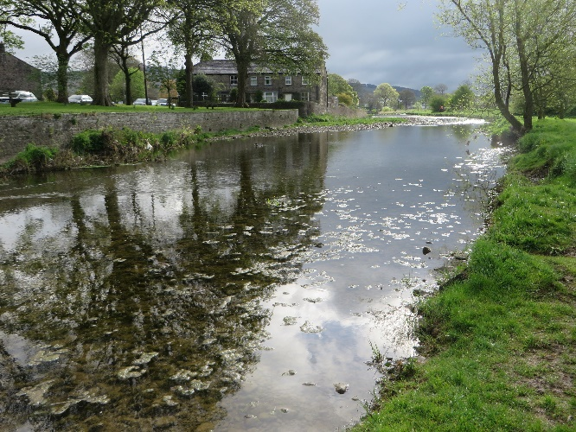 7
Photos along Malham Beck
- Near to the base of Malham Cove.
- Just upstream of the bridge in Malham.
- Opposite the car park in Malham.
- Translands Beck flowing into Malham Beck.
- Scalegill Mill, north of Hanlith.
- Airton.
- Gargrave.

