****

Name: \_\_\_\_\_\_\_\_\_\_\_\_\_\_\_\_\_\_\_\_\_\_\_\_\_\_\_\_\_\_\_\_\_ Teacher / class: \_\_\_\_\_\_\_\_\_\_\_\_\_\_

Physical Geography Fieldwork: Rivers Study in Malham

|  |  |  |
| --- | --- | --- |
| The aims of today are to:   1. Experience collecting a variety of information that you will need for Paper 3. 2. To develop your knowledge & understanding of river processes and physical landscapes. 3. To enjoy experiencing Geography in the outdoors. | | |
| Map showing the location of Malham village.    [Image result for north arrow](https://www.google.co.uk/url?sa=i&rct=j&q=&esrc=s&source=images&cd=&cad=rja&uact=8&ved=0ahUKEwj8ktPOmrXTAhVhIcAKHb2EBnUQjRwIBw&url=https://openclipart.org/detail/100207/north-arrow-orienteering&psig=AFQjCNHZmhit4YDF14bmt9uGXGNLrg14Dg&ust=1492852375850115) | | Describe the location of Malham. |
| Map showing Malham village and the surrounding river systems.  Gordale Scar  [Image result for north arrow](https://www.google.co.uk/url?sa=i&rct=j&q=&esrc=s&source=images&cd=&cad=rja&uact=8&ved=0ahUKEwj8ktPOmrXTAhVhIcAKHb2EBnUQjRwIBw&url=https://openclipart.org/detail/100207/north-arrow-orienteering&psig=AFQjCNHZmhit4YDF14bmt9uGXGNLrg14Dg&ust=1492852375850115)  Malham  Beck  Gordale  Beck  YDNP  car park | An OS map showing Malham and surrounding area. | |

Aim and theory

**The aim of your fieldwork investigation is to examine how Malham Beck / Gordale Beck changes downstream.**

How would you expect a river to change downstream? The **Bradshaw Model** made some predictions.

Complete the table by underlining whether each factor is likely to increase to decrease.

|  |  |
| --- | --- |
| Discharge | Increase / decrease |
| Channel depth | Increase / decrease |
| Velocity | Increase / decrease |
| Channel width | Increase / decrease |
| Load quantity | Increase / decrease |
| Load particle size | Increase / decrease |
| Channel bed roughness | Increase / decrease |
| Gradient | Increase / decrease |

Your fieldwork will focus upon **velocity** and **cross sectional area**.

Hypothesis 1: The velocity of the river will \_\_\_\_\_\_\_\_\_\_\_\_\_\_\_\_\_\_\_\_\_\_\_\_downstream.

Hypothesis 2: The cross sectional area will \_\_\_\_\_\_\_\_\_\_\_\_\_\_\_\_\_\_\_\_\_\_\_\_downstream.

Risk Assessment

|  |  |  |  |
| --- | --- | --- | --- |
| **Potential hazard** | **Likelihood of happening (1-5)**  **5 = most likely** | **Severity of impact (1-5)**  **5 = most severe** | **Control measures** |
|  |  |  |  |
|  |  |  |  |
|  |  |  |  |

[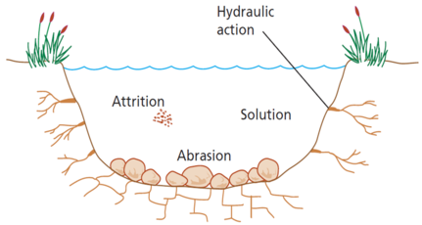](http://www.google.co.uk/url?sa=i&rct=j&q=&esrc=s&source=images&cd=&cad=rja&uact=8&ved=0ahUKEwjghpm9j9PTAhWGvBQKHSjOBqYQjRwIBw&url=http://www.geographypods.com/21-river-features.html&psig=AFQjCNHgPvvIUxCNINFk6BX7eCUVNMUKtw&ust=1493880137036525)

Methods of data collection

In the exam, you may be have to describe and reflect upon your data collection methods.

|  |  |  |
| --- | --- | --- |
| **Measurement** | **Description, diagram and justification** | **Limitations and improvements** |
| Channel width |  |  |
| Channel depth |  |  |
| Velocity |  |  |

All of the three measurements in the table above are **quantitative** information as they use numerical data. Identify two methods of **qualitative** data that you may use to help you.

|  |  |
| --- | --- |
| 1 |  |
| 2 |  |

State two **secondary** sources of information that would help you with your fieldwork investigation.

|  |  |
| --- | --- |
| 1 |  |
| 2 |  |

How might you use **ICT** to help your fieldwork investigation?

|  |
| --- |
|  |

Data recording 1

|  |  |  |  |  |  |  |  |  |  |  |  |  |  |  |
| --- | --- | --- | --- | --- | --- | --- | --- | --- | --- | --- | --- | --- | --- | --- |
| Site number: | | | | | Location: | | | | | Distance from… | | | | |
| Observations of the surrounding area:  [Image result for observation eyes](https://www.google.co.uk/url?sa=i&rct=j&q=&esrc=s&source=images&cd=&cad=rja&uact=8&ved=0ahUKEwie16PdqbXTAhUgOsAKHVEHB28QjRwIBw&url=https://www.pinterest.com/pin/332914597426937351/&psig=AFQjCNGMWxf1ONf3_w6cYgVuiyuFzcXfbg&ust=1492856423817545) | | | | | | | | | | | | | | |
| Observations of the river:  [Image result for observation eyes](https://www.google.co.uk/url?sa=i&rct=j&q=&esrc=s&source=images&cd=&cad=rja&uact=8&ved=0ahUKEwie16PdqbXTAhUgOsAKHVEHB28QjRwIBw&url=https://www.pinterest.com/pin/332914597426937351/&psig=AFQjCNGMWxf1ONf3_w6cYgVuiyuFzcXfbg&ust=1492856423817545) | | | | | | | | | | | | | | |
| Annotated sketch of the river: | | | | | | | | | | | | | | |
| Channel width (m): | | | | | | | | | | | | | | |
| Divide the channel width by 10 to give you the interval between each point where you will measure the depth of the channel. \_\_\_\_\_\_ Measure from the left hand bank facing downstream. | | | | | | | | | | | | | | |
|  | 1 | 2 | 3 | 4 | | 5 | 6 | 7 | 8 | | 9 | 10 | 11 | Mean |
| Distance from bank(m) | 0 |  |  |  | |  |  |  |  | |  |  |  | - |
| Depth of water (cm) |  |  |  |  | |  |  |  |  | |  |  |  |  |

Velocity – use a stopwatch to record the time that it takes for a float to travel over 10 metres. Do this three times.

|  |  |  |  |  |
| --- | --- | --- | --- | --- |
|  | 1 | 2 | 3 | Mean |
| Time taken |  |  |  |  |
| m/s |  |  |  |  |

|  |
| --- |
| Extra: How you could measure the gradient? |

Data recording 2

|  |  |  |  |  |  |  |  |  |  |  |  |  |  |  |
| --- | --- | --- | --- | --- | --- | --- | --- | --- | --- | --- | --- | --- | --- | --- |
| Site number: | | | | | Location: | | | | | Distance from… | | | | |
| Observations of the surrounding area:  [Image result for observation eyes](https://www.google.co.uk/url?sa=i&rct=j&q=&esrc=s&source=images&cd=&cad=rja&uact=8&ved=0ahUKEwie16PdqbXTAhUgOsAKHVEHB28QjRwIBw&url=https://www.pinterest.com/pin/332914597426937351/&psig=AFQjCNGMWxf1ONf3_w6cYgVuiyuFzcXfbg&ust=1492856423817545) | | | | | | | | | | | | | | |
| Observations of the river:  [Image result for observation eyes](https://www.google.co.uk/url?sa=i&rct=j&q=&esrc=s&source=images&cd=&cad=rja&uact=8&ved=0ahUKEwie16PdqbXTAhUgOsAKHVEHB28QjRwIBw&url=https://www.pinterest.com/pin/332914597426937351/&psig=AFQjCNGMWxf1ONf3_w6cYgVuiyuFzcXfbg&ust=1492856423817545) | | | | | | | | | | | | | | |
| Annotated sketch of the river: | | | | | | | | | | | | | | |
| Channel width (m): | | | | | | | | | | | | | | |
| Divide the channel width by 10 to give you the interval between each point where you will measure the depth of the channel. \_\_\_\_\_\_\_ Measure from the left hand bank facing upstream. | | | | | | | | | | | | | | |
|  | 1 | 2 | 3 | 4 | | 5 | 6 | 7 | 8 | | 9 | 10 | 11 | Mean |
| Distance from bank(m) |  |  |  |  | |  |  |  |  | |  |  |  | - |
| Depth (cm) |  |  |  |  | |  |  |  |  | |  |  |  |  |

Velocity – use a stopwatch to record the time that it takes for a float to travel over 10 metres. Do this three times.

|  |  |  |  |
| --- | --- | --- | --- |
|  | 1 | 2 | 3 |
| Time taken |  |  |  |
| m/s |  |  |  |

|  |
| --- |
| Extra: How you could measure the bed load? |

Data recording 3

|  |  |  |  |  |  |  |  |  |  |  |  |  |  |  |
| --- | --- | --- | --- | --- | --- | --- | --- | --- | --- | --- | --- | --- | --- | --- |
| Site number: | | | | | Location: | | | | | Distance from… | | | | |
| Observations of the surrounding area:  [Image result for observation eyes](https://www.google.co.uk/url?sa=i&rct=j&q=&esrc=s&source=images&cd=&cad=rja&uact=8&ved=0ahUKEwie16PdqbXTAhUgOsAKHVEHB28QjRwIBw&url=https://www.pinterest.com/pin/332914597426937351/&psig=AFQjCNGMWxf1ONf3_w6cYgVuiyuFzcXfbg&ust=1492856423817545) | | | | | | | | | | | | | | |
| Observations of the river:  [Image result for observation eyes](https://www.google.co.uk/url?sa=i&rct=j&q=&esrc=s&source=images&cd=&cad=rja&uact=8&ved=0ahUKEwie16PdqbXTAhUgOsAKHVEHB28QjRwIBw&url=https://www.pinterest.com/pin/332914597426937351/&psig=AFQjCNGMWxf1ONf3_w6cYgVuiyuFzcXfbg&ust=1492856423817545) | | | | | | | | | | | | | | |
| Annotated sketch of the river: | | | | | | | | | | | | | | |
| Channel width (m): | | | | | | | | | | | | | | |
| Divide the channel width by 10 to give you the interval between each point where you will measure the depth of the channel. \_\_\_\_\_\_\_ Measure from the left hand bank facing upstream. | | | | | | | | | | | | | | |
|  | 1 | 2 | 3 | 4 | | 5 | 6 | 7 | 8 | | 9 | 10 | 11 | Mean |
| Distance from bank(m) |  |  |  |  | |  |  |  |  | |  |  |  | - |
| Depth (cm) |  |  |  |  | |  |  |  |  | |  |  |  |  |

Velocity – use a stopwatch to record the time that it takes for a float to travel over 10 metres. Do this three times.

|  |  |  |  |
| --- | --- | --- | --- |
|  | 1 | 2 | 3 |
| Time taken |  |  |  |
| m/s |  |  |  |

|  |
| --- |
| Extra: How you could measure the wetted perimeter? |

The photograph directly below shows Malham Beck near to Scalegill Mill, which is about 1km south (downstream) of Malham.

|  |  |  |
| --- | --- | --- |
| C:\Users\pjhic\OneDrive\Pictures\Photos\Photos @ 2017\Photos\Post July 2014\2017\IMG_4972.JPG | | How do you think the river has changed compared to when it flowed through Malham? Explain your answer. |
| Photo facing upstream showing the confluence between Malham Beck and Tranlands Beck 500 metres south of Malham.  C:\Users\pjhic\OneDrive\Pictures\Photos\Photos @ 2017\Photos\Post July 2014\2017\IMG_4977.JPG | Photo facing downstream of the confluence in the photo on the left. Think about run-off & vegetation.  C:\Users\pjhic\OneDrive\Pictures\Photos\Photos @ 2017\Photos\Post July 2014\2017\IMG_4976.JPG | |

|  |  |
| --- | --- |
| C:\Users\pjhic\OneDrive\Pictures\Photos\Photos @ 2017\Photos\Post July 2014\2017\IMG_4950.JPG | Describe how Malham Beck has been affected by human geography. |

Add annotations to the photograph showing a small meander on Gordale Beck.

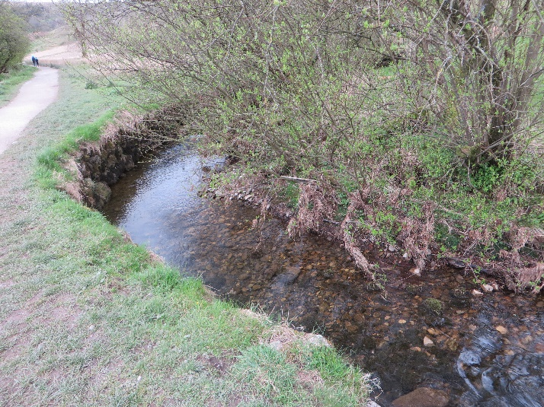

The photograph below is similar to the previous one as it shows a small meander on Gordale Beck (located between Gordale Scar and Janet’s Foss at Gordale campsite). Both photographs show how people can affect the physical geography of an area.

|  |  |
| --- | --- |
| C:\Users\pjhic\OneDrive\Pictures\Photos\Photos @ 2017\Photos\Post July 2014\2017\IMG_4997.JPG | Explain the human impact upon Gordale Beck. |

Annotate the photograph showing Gordale Scar. Include possible explanations of how it may have been formed.

[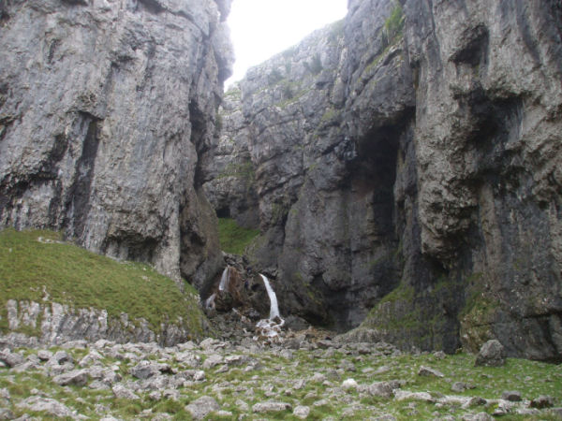](https://www.google.co.uk/url?sa=i&rct=j&q=&esrc=s&source=images&cd=&cad=rja&uact=8&ved=0ahUKEwia5fPPubXTAhUlKcAKHWbpAXYQjRwIBw&url=http://www.yorkshire-dales.com/malham/gordale-scar-views.html&psig=AFQjCNHueaxFj1RKfzrVxVxbyjURKMBj0Q&ust=1492860170509919)

Underline the words that are associated with the landscape surrounding Malham Cove.

Can you label the relevant ones onto the photograph?

|  |  |  |  |  |  |
| --- | --- | --- | --- | --- | --- |
| Carboniferous limestone | granite | coniferous plantation | limestone pavement | resurgence spring | ox-bow lake |

[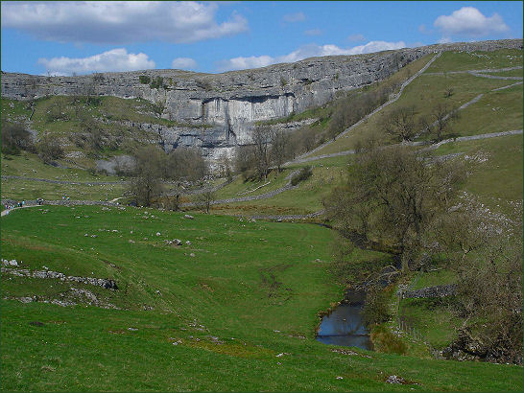](https://www.google.co.uk/url?sa=i&rct=j&q=&esrc=s&source=images&cd=&cad=rja&uact=8&ved=0ahUKEwia5pCQt7XTAhWoCcAKHWvkDG8QjRwIBw&url=http://www.yorkshireguides.com/malham_cove.html&psig=AFQjCNFR2f6PyU-5g3eogn6UjGQhreqU3w&ust=1492859995890538)

|  |  |  |  |  |  |
| --- | --- | --- | --- | --- | --- |
| pastoral land use | dry stone walls | wide lowland floodplain | deciduous trees | rock outcrop | Malham Beck (flows into the River Aire) |

|  |
| --- |
| Extra: Add other notes about the landscape surrounding Malham Cove |

To what extent do you think that Malham Cove / Gordale Scar is a spectacular UK landscape? Put a tick along the opinion line and briefly justify your answer.

[Image result for arrow upImage result for arrow upImage result for arrow upImage result for arrow up](https://www.google.co.uk/url?sa=i&rct=j&q=&esrc=s&source=images&cd=&cad=rja&uact=8&ved=0ahUKEwj_or-WvrXTAhVBCcAKHRaRCHAQjRwIBw&url=https://clipartfest.com/categories/view/dc835f4e03e6b6272cf2909c90b0b16c73dfb252/green-up-arrow.html&psig=AFQjCNFA_RkX3cbuYfSMdeJOLYqNYn3CKw&ust=1492861782607638)

|  |
| --- |
| Very large Large Don’t sit on the fence Small Very small  extent extent extent extent |
| Justification: |