**GCSE URBAN FIELDWORK**

**Data Collection Booklet**

Name: Teacher: PHk

Hypothesis 1

Environmental quality increases with distance from the centre of an urban area.

Hypothesis 2

There are many factors which contribute to Environmental Quality

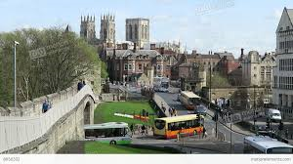

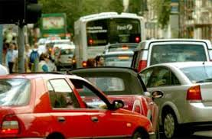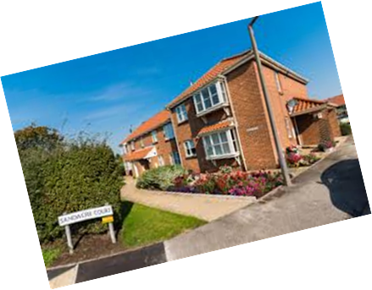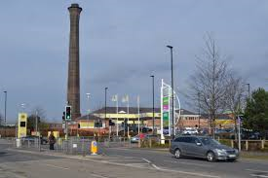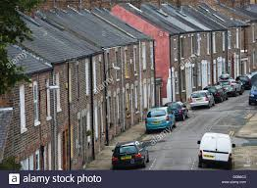

|  |
| --- |
| **Site 1**  **Location**  **Distance from centre of York** |
| **Epitome Words and/or Photo Labels** |
| **Traffic Count** – work in pairs – one of you counts vehicles travelling in one direction, one of you does the other direction. Count for FIVE minutes. Add your scores together then total ALL the vehicles that went past in 5 minutes.   |  |  |  |  | | --- | --- | --- | --- | |  | **My Tally** | **Partner’s Tally** | **TOTAL** | | Cars  Lorries/vans  Motorbikes  Bicycles  Coaches/buses  Other |  |  |  | | **Total of all vehicles** | | |  | |
| **Tourist Facilities/ Tourism Indicator**  Count how many of each of these tourist facilities you can see within 200m (approx.) from where you are standing:  Attractions/landmarks  Tourist shop  Tourist service  Other  Total (Tourism Index) |
| **Environmental Quality ( bi polar) Survey**   |  |  |  |  |  |  |  | | --- | --- | --- | --- | --- | --- | --- | | **Poor EQ** | **-2** | **-1** | **0** | **+1** | **+2** | **Good EQ** | | NOISY |  |  |  |  |  | QUIET | | OBVIOUS SMELL FROM FUMES/POLLUTION |  |  |  |  |  | NO SMELL FROM TRAFFIC OR OTHER POLLUTION | | VERY LITTLE OPEN SPACE/DERELICT OPEN SPACE |  |  |  |  |  | PLENTY OF WELL MAINTAINED AND GREEN OPEN SPACE | | POOR BUILDING MAINTENANCE |  |  |  |  |  | BUILDINGS WELL MAINTAINED | | EXTENSIVE VANDALISM/GRAFFITI/LITTER |  |  |  |  |  | NO VANDALISM/GRAFFITI/LITTER | | AREA FEELS UNSAFE (imagine at night) |  |  |  |  |  | AREA FEELS SAFE (imagine at night) | | BUIDLINGS UGLY |  |  |  |  |  | BUILDINGS AESTHETICALLY PLEASING |   **TOTAL EQ SCORE:** |

**ANY OTHER OBSERVATIONS**:

|  |
| --- |
| **Site 2**  **Location**  **Distance from centre of York** |
| **Epitome Words and/or Photo Labels** |
| **Traffic Count** – work in pairs – one of you counts vehicles travelling in one direction, one of you does the other direction. Count for FIVE minutes. Add your scores together then total ALL the vehicles that went past in 5 minutes.   |  |  |  |  | | --- | --- | --- | --- | |  | **My Tally** | **Partner’s Tally** | **TOTAL** | | Cars  Lorries/vans  Motorbikes  Bicycles  Coaches/buses  Other |  |  |  | | **Total of all vehicles** | | |  | |
| **Tourist Facilities/ Tourism Indicator**  Count how many of each of these tourist facilities you can see within 200m (approx.) from where you are standing:  Attractions/landmarks  Tourist shop  Tourist service  Other  Total (Tourism Index) |
| **Environmental Quality ( bi polar) Survey**   |  |  |  |  |  |  |  | | --- | --- | --- | --- | --- | --- | --- | | **Poor EQ** | **-2** | **-1** | **0** | **+1** | **+2** | **Good EQ** | | NOISY |  |  |  |  |  | QUIET | | OBVIOUS SMELL FROM FUMES/POLLUTION |  |  |  |  |  | NO SMELL FROM TRAFFIC OR OTHER POLLUTION | | VERY LITTLE OPEN SPACE/DERELICT OPEN SPACE |  |  |  |  |  | PLENTY OF WELL MAINTAINED AND GREEN OPEN SPACE | | POOR BUILDING MAINTENANCE |  |  |  |  |  | BUILDINGS WELL MAINTAINED | | EXTENSIVE VANDALISM/GRAFFITI/LITTER |  |  |  |  |  | NO VANDALISM/GRAFFITI/LITTER | | AREA FEELS UNSAFE (imagine at night) |  |  |  |  |  | AREA FEELS SAFE (imagine at night) | | BUIDLINGS UGLY |  |  |  |  |  | BUILDINGS AESTHETICALLY PLEASING |   **TOTAL EQ SCORE:** |

**ANY OTHER OBSERVATIONS**:

|  |
| --- |
| **Site 3**  **Location**  **Distance from centre of York** |
| **Epitome Words and/or Photo Labels** |
| **Traffic Count** – work in pairs – one of you counts vehicles travelling in one direction, one of you does the other direction. Count for FIVE minutes. Add your scores together then total ALL the vehicles that went past in 5 minutes.   |  |  |  |  | | --- | --- | --- | --- | |  | **My Tally** | **Partner’s Tally** | **TOTAL** | | Cars  Lorries/vans  Motorbikes  Bicycles  Coaches/buses  Other |  |  |  | | **Total of all vehicles** | | |  | |
| **Tourist Facilities/ Tourism Indicator**  Count how many of each of these tourist facilities you can see within 200m (approx.) from where you are standing:  Attractions/landmarks  Tourist shop  Tourist service  Other  Total (Tourism Index) |
| **Environmental Quality ( bi polar) Survey**   |  |  |  |  |  |  |  | | --- | --- | --- | --- | --- | --- | --- | | **Poor EQ** | **-2** | **-1** | **0** | **+1** | **+2** | **Good EQ** | | NOISY |  |  |  |  |  | QUIET | | OBVIOUS SMELL FROM FUMES/POLLUTION |  |  |  |  |  | NO SMELL FROM TRAFFIC OR OTHER POLLUTION | | VERY LITTLE OPEN SPACE/DERELICT OPEN SPACE |  |  |  |  |  | PLENTY OF WELL MAINTAINED AND GREEN OPEN SPACE | | POOR BUILDING MAINTENANCE |  |  |  |  |  | BUILDINGS WELL MAINTAINED | | EXTENSIVE VANDALISM/GRAFFITI/LITTER |  |  |  |  |  | NO VANDALISM/GRAFFITI/LITTER | | AREA FEELS UNSAFE (imagine at night) |  |  |  |  |  | AREA FEELS SAFE (imagine at night) | | BUIDLINGS UGLY |  |  |  |  |  | BUILDINGS AESTHETICALLY PLEASING |   **TOTAL EQ SCORE:** |

**ANY OTHER OBSERVATIONS**:

|  |
| --- |
| **Site 4**  **Location**  **Distance from centre of York** |
| **Epitome Words and/or Photo Labels** |
| **Traffic Count** – work in pairs – one of you counts vehicles travelling in one direction, one of you does the other direction. Count for FIVE minutes. Add your scores together then total ALL the vehicles that went past in 5 minutes.   |  |  |  |  | | --- | --- | --- | --- | |  | **My Tally** | **Partner’s Tally** | **TOTAL** | | Cars  Lorries/vans  Motorbikes  Bicycles  Coaches/buses  Other |  |  |  | | **Total of all vehicles** | | |  | |
| **Tourist Facilities/ Tourism Indicator**  Count how many of each of these tourist facilities you can see within 200m (approx.) from where you are standing:  Attractions/landmarks  Tourist shop  Tourist service  Other  Total (Tourism Index) |
| **Environmental Quality ( bi polar) Survey**   |  |  |  |  |  |  |  | | --- | --- | --- | --- | --- | --- | --- | | **Poor EQ** | **-2** | **-1** | **0** | **+1** | **+2** | **Good EQ** | | NOISY |  |  |  |  |  | QUIET | | OBVIOUS SMELL FROM FUMES/POLLUTION |  |  |  |  |  | NO SMELL FROM TRAFFIC OR OTHER POLLUTION | | VERY LITTLE OPEN SPACE/DERELICT OPEN SPACE |  |  |  |  |  | PLENTY OF WELL MAINTAINED AND GREEN OPEN SPACE | | POOR BUILDING MAINTENANCE |  |  |  |  |  | BUILDINGS WELL MAINTAINED | | EXTENSIVE VANDALISM/GRAFFITI/LITTER |  |  |  |  |  | NO VANDALISM/GRAFFITI/LITTER | | AREA FEELS UNSAFE (imagine at night) |  |  |  |  |  | AREA FEELS SAFE (imagine at night) | | BUIDLINGS UGLY |  |  |  |  |  | BUILDINGS AESTHETICALLY PLEASING |   **TOTAL EQ SCORE:** |

**ANY OTHER OBSERVATIONS**:

|  |
| --- |
| **Site 5**  **Location**  **Distance from centre of York** |
| **Epitome Words and/or Photo Labels** |
| **Traffic Count** – work in pairs – one of you counts vehicles travelling in one direction, one of you does the other direction. Count for FIVE minutes. Add your scores together then total ALL the vehicles that went past in 5 minutes.   |  |  |  |  | | --- | --- | --- | --- | |  | **My Tally** | **Partner’s Tally** | **TOTAL** | | Cars  Lorries/vans  Motorbikes  Bicycles  Coaches/buses  Other |  |  |  | | **Total of all vehicles** | | |  | |
| **Tourist Facilities/ Tourism Indicator**  Count how many of each of these tourist facilities you can see within 200m (approx.) from where you are standing:  Attractions/landmarks  Tourist shop  Tourist service  Other  Total (Tourism Index) |
| **Environmental Quality ( bi polar) Survey**   |  |  |  |  |  |  |  | | --- | --- | --- | --- | --- | --- | --- | | **Poor EQ** | **-2** | **-1** | **0** | **+1** | **+2** | **Good EQ** | | NOISY |  |  |  |  |  | QUIET | | OBVIOUS SMELL FROM FUMES/POLLUTION |  |  |  |  |  | NO SMELL FROM TRAFFIC OR OTHER POLLUTION | | VERY LITTLE OPEN SPACE/DERELICT OPEN SPACE |  |  |  |  |  | PLENTY OF WELL MAINTAINED AND GREEN OPEN SPACE | | POOR BUILDING MAINTENANCE |  |  |  |  |  | BUILDINGS WELL MAINTAINED | | EXTENSIVE VANDALISM/GRAFFITI/LITTER |  |  |  |  |  | NO VANDALISM/GRAFFITI/LITTER | | AREA FEELS UNSAFE (imagine at night) |  |  |  |  |  | AREA FEELS SAFE (imagine at night) | | BUIDLINGS UGLY |  |  |  |  |  | BUILDINGS AESTHETICALLY PLEASING |   **TOTAL EQ SCORE:** |

**ANY OTHER OBSERVATIONS**:

ROUTE 1 (Red)

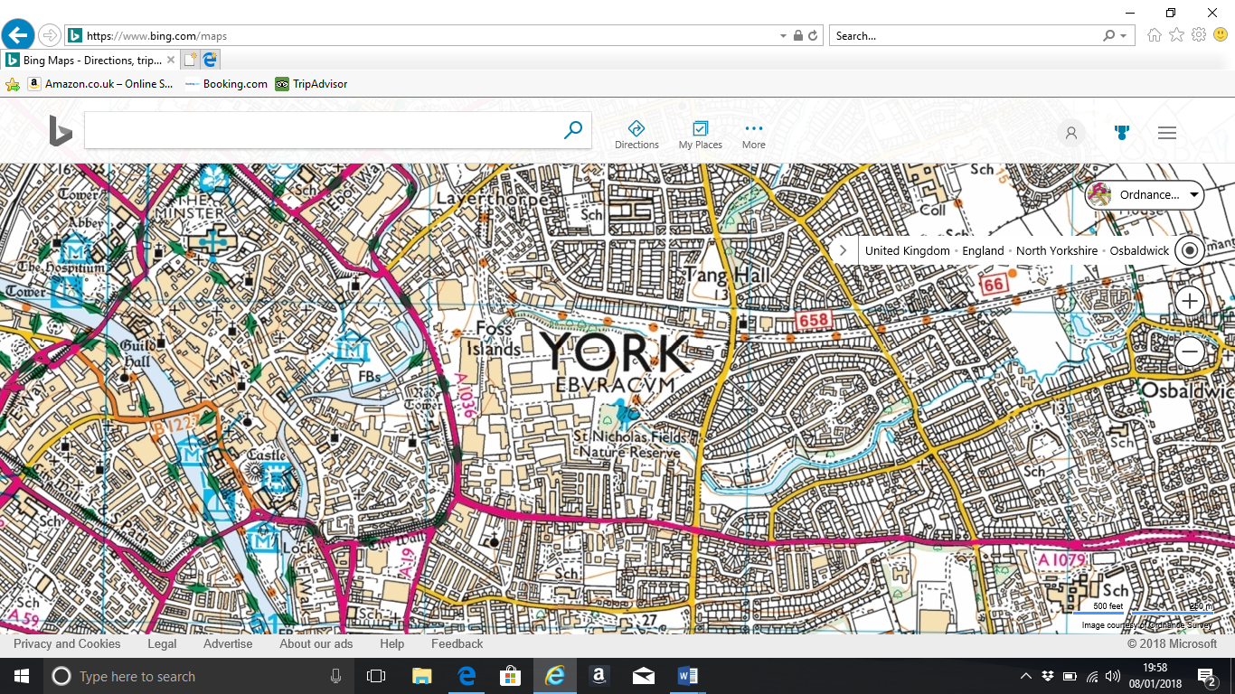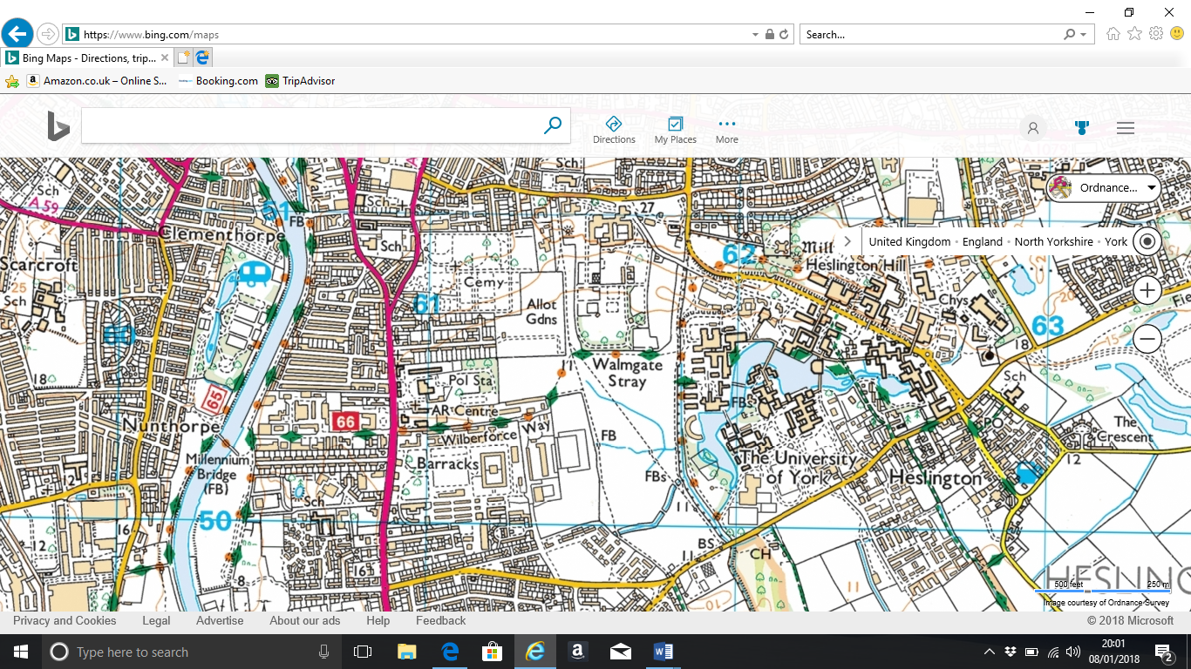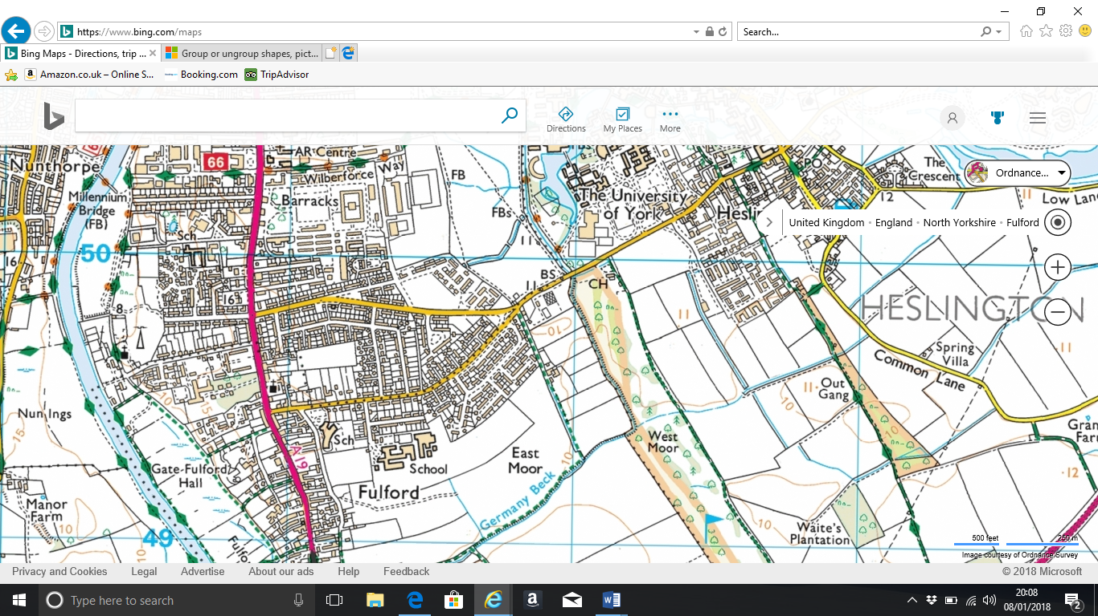

1. Castlegate/Hilton Hotel 4. Aldreth Grove
2. Terry Avenue 5. Norway Drive
3. Bishopthorpe Road (shops)

 Survey sites

 Return route

**Points of interest to mention**: Site of Clementhorpe Aqua Barrier; Gentrification in Bishopthorpe road area;

**Suggested lunch stop**: Rowntree’s Park (near Millennium Bridge)

**Urban Geography notes**